Gasoline Engine
Owner’s Manual
LC152F-1
LC154F-1
LC156F-1

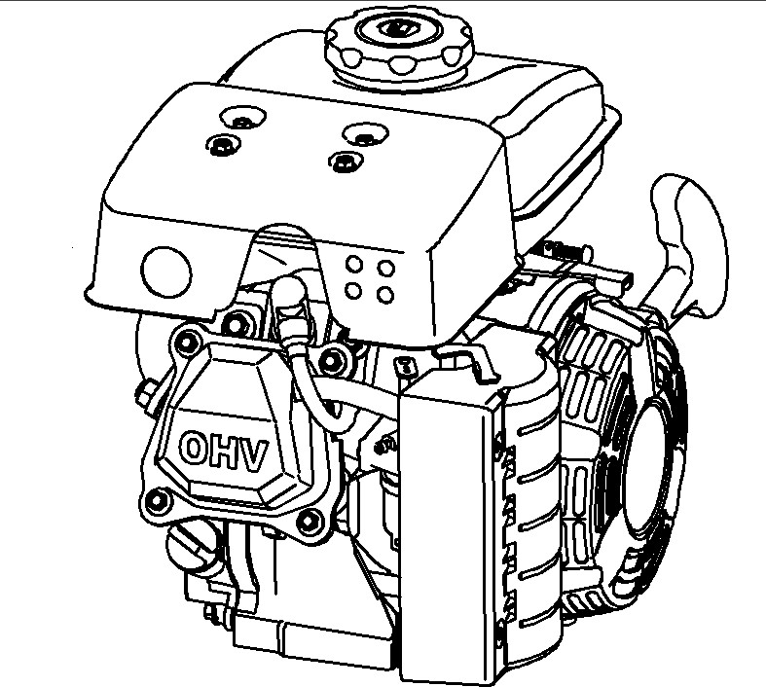

CONTENTS

1. ENGINE SAFETY........................................................................................2
2. COMPONENTS & CONTROL LOCATIONS…………………………………………3
3. CONTROLS..........................................................................................4
Fuel cock
Engine switch
Choke lever
Recoil starter
Governor lever
Oil alert
4. CHECK BEFORE OPERATION .............................................................................. 6
Check
Check oil
Check fuel
Check air cleaner
5. STARTING ENGINE........................................................................................................8
6. STOP ENGINE …………………………………………………………………...................10
7. MAINTENANCE ……………………………………………………………………………...11
Schedule
Renewing engine oil
Maintaining air cleaner
Washing sediment cup
Spark plug
Adjusting idle speed
8. STORAGE …………………………………………………………………………………….16
9. TROUBLSHOOTING ………………………………………………………………………...18
10. ENGINE PARAMETER……………………………………………………………………..21
11. Wiring Diagrams………………………………………………………………………..22

1. ENGINE SAFETY

IMPORTANT SAFETY INFORMATION

Most accidents with engines can be prevented if you follow all instructions in this manual and on the engine. Some of the most common hazards are discussed below, along with the best way to protect yourself and others.

Owner Responsibilities

- The engines are designed to give safe and dependable service if operated according to instructions. Read and understand this owner’s manual before operating the engine. Failure to do so could result in personal injury or equipment damage.

- Know how to stop the engine quickly, and understand the operation of all controls. Never permit anyone to operate the engine without proper instructions.

- Do not allow children to operate the engine. Keep children and pets far away from the area of operation.

Refuel With Care

Gasoline is extremely flammable, and gasoline vapor can explode. Refuel outdoors, in a well-ventilated area, with the engine stopped. Never smoke near gasoline, and keep other flames and sparks away. Always store gasoline in an approved container. If any fuel is spilled, make sure the area is dry before starting the engine.

Hot Exhaust

- The muffler becomes very hot during operation and remains hot for a while after stopping the engine. Be careful not to touch the muffler while it is hot. Let the engine cool before storing it indoors.

- To prevent fire hazards and to provide adequate ventilation for stationary equipment applications, keep the engine at least 3 feet (1 meter) away from building walls and other equipment during operation. Do not place flammable objects close to the engine.

Carbon Monoxide Hazard

Exhaust gas contains poisonous carbon monoxide. Avoid inhalation of exhaust gas. Never run the engine in a closed garage or confined area.

2. COMPONENTS & CONTROL LOCATIONS
Fuel tank
Cover
Choke lever
Muffler

Throttle control assy.
Starting lever
Recoil starter
Air cleaner
Spark plug
Cylinder head cover

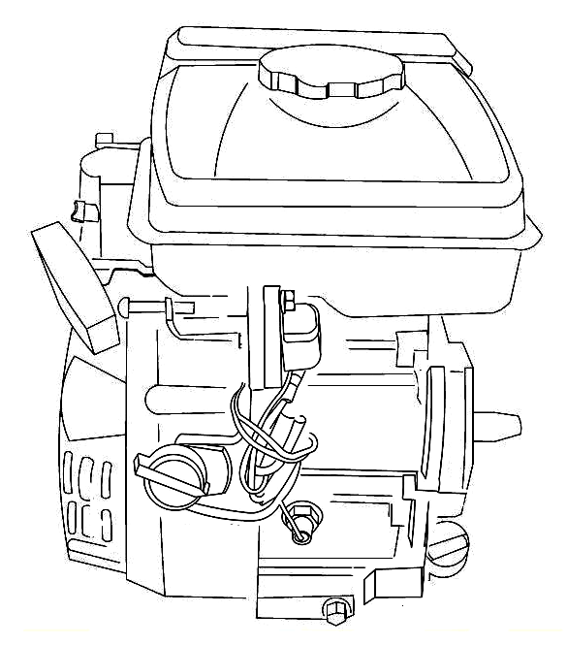
Oil alert
Switch
Oil sensor
Oil dipstick
Drain plug
3. CONTROLS
1) Engine Switch

The engine switch enables and disables the ignition system.
The engine switch must be in the ON position for the engine to run.
Turning the engine switch to the OFF position stops the engine.
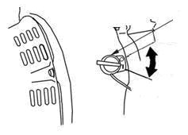
The engine switch
OFF
ON
2) Choke Lever

The choke lever opens and closes the choke valve in the carburetor.
Set lever “CLOSE” for starting a cold engine.
After starting, set the choke lever to “OPEN” position

Choke lever

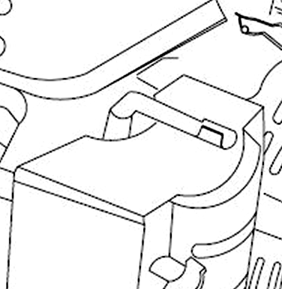
Close
Open

3) Recoil Starter Grip

Pulling the starter grip operates the recoil starter to crank the engine.

Don’t let the lever suddenly rebound, lightly put the lever back.
CAUTION

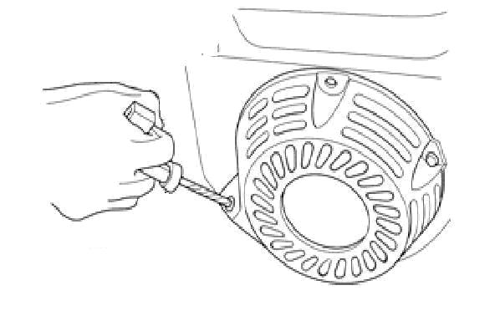
Starter grip

- Governor lever

Adjust the throttle lever position to get required speed.

high low
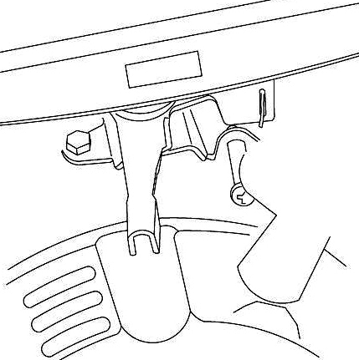
Throttle lever

For proper engine speed, refer to indication provided by equipment.

- Oil protecting system

The oil protecting system is used for preventing from oil insufficiency in the crankcase, when oil lowering lower limit, the oil protecting system will automatically make the engine stopping.(engine still keep the “OPEN” position.)
CAUTION
If automatically stopping and not starting, first, check the oil lever, then, check other trouble.
4. CHECK BEFORE OPERATION

1) Check
- Look around and underneath the engine for signs of oil or gasoline leaks.
- Look for signs of damage.
- Check that all shields and covers are in place, and all nuts, bolts, and screws are tightened.

2) Check oil
CAUTION
When stopping the engine at horizontal place, check the oil

- Take the oil dipstick and clean
- Insert the oil dipstick in and check the oil lever without screwing down.
- If the oil is too low, add the recommenced oil in.
- After finishing, reassemble and screw the oil dipstick down.
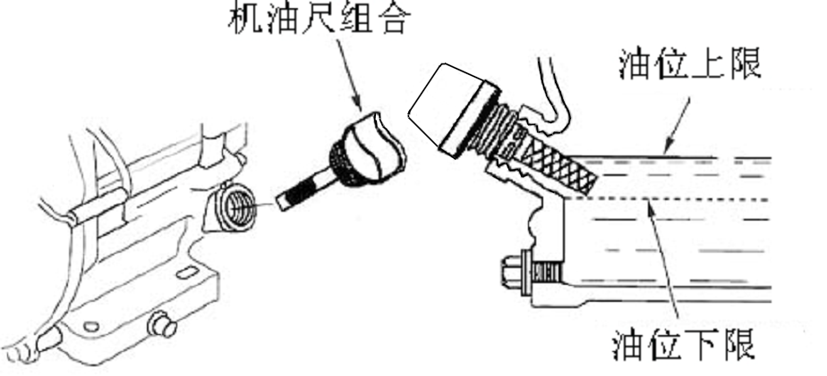
UPPER OIL LEVEL
LOWER OIL LEVEL
OIL DIPSTICK

The Oil Alert system (applicable engine types) will automatically stop the engine before the oil level falls below safe limits. However, to avoid the inconvenience of an unexpected shutdown, always check the engine oil level before startup.

3) Check fuel

First stop the engine, open the fuel cover, and check oil level., if the oil level is too low, add the fuel to full, after finishing, screw the fuel cover down.
Don’t add the fuel over the shoulder of the carburetor when fueling (maximum oil level).

Fuel tank volume：
152F-1/154F-1/156F-1-：1.6 L

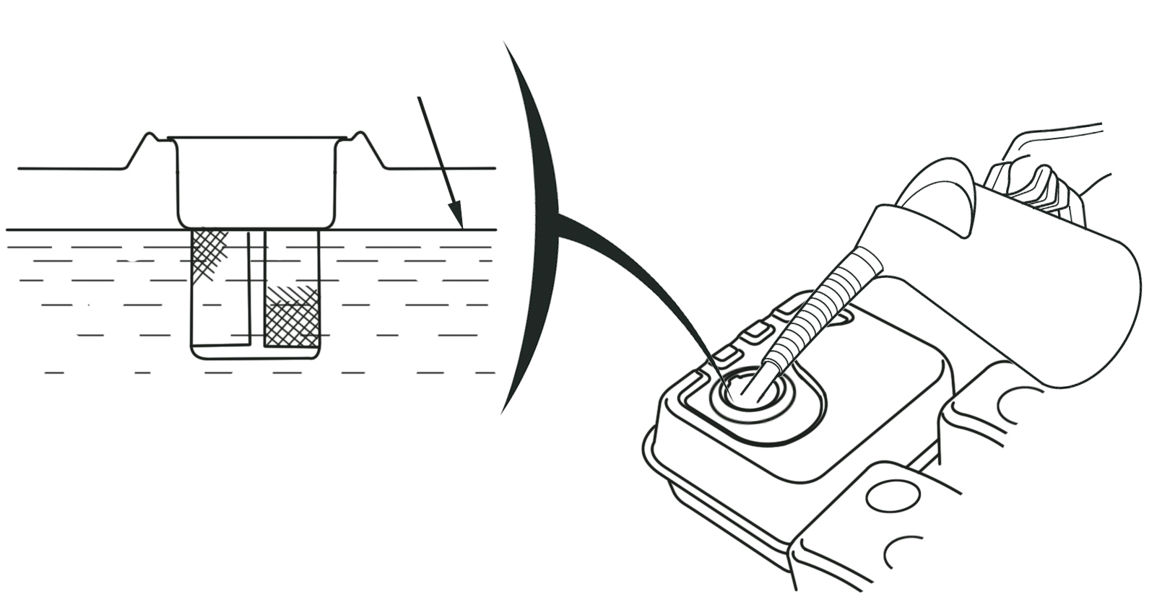
Maximum fuel oil level

Recommended octane rating over 90 unleaded gasoline
For unleaded gasoline, can make carbon deposit muck less and enhance exhaust system service life

Don’t use used and contaminated or gasoline with oil , Avoid the dirt and water entering into fuel tank.

4) Check air cleaner

Remove the air cleaner housing and check the element, if the element dirt, clean it, if damaged, renew.

Air cleaner
elbow
Supporting platee
Element
Cover

Screw
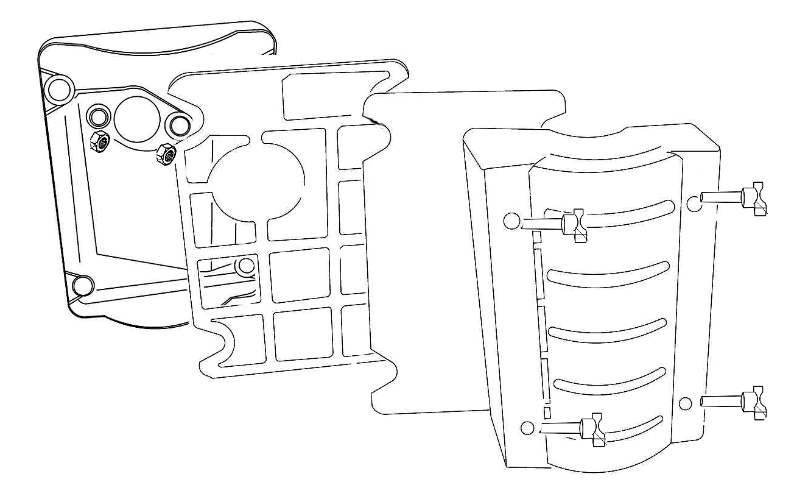
Nut M6

5. STARTING ENGINE
1) To start a cold engine, move the choke lever to the “CLOSE “position.
To start a warm engine, turn the choke lever to the” OPEN” position.
Choke lever

Close

Open

2) Move the throttle lever away from the “LOW” position, about 1/3 of the way toward the “HIGH” position.
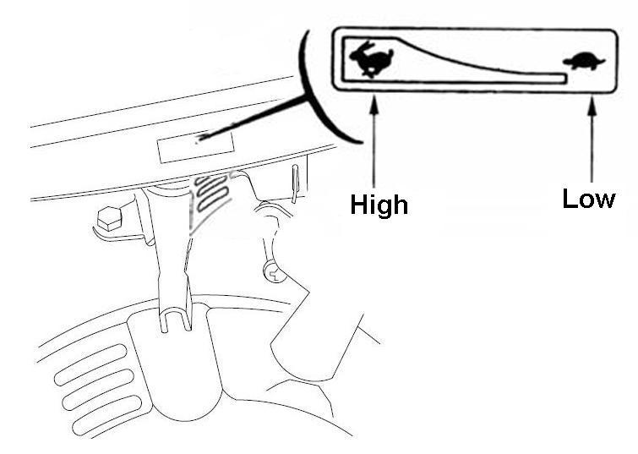
Governor lever

- Turn the engine switch to the “ON “position.
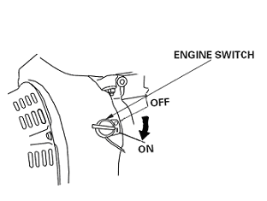
ON
The engine switch

- Pull the starter grip lightly until you feel resistance, then pull briskly.
Don’t let starting lever suddenly rebound, and lightly put the lever back.

CAUTION

Starter grip

- If the choke lever has been moved to the “CLOSE” position to start the engine, gradually move it to the” OPEN” position as the engine warms up.

Choke lever

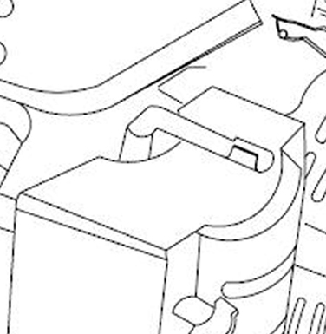
Open
6. STOPPING THE ENGINE

To stop the engine in an emergency, simply turn the engine switch to the “OFF” position. Under normal conditions, use the following procedure.

1). Move the throttle lever to the “LOW” position.

High low

Throttle lever

- Turn the engine switch to the “OFF” position.

The engine switch
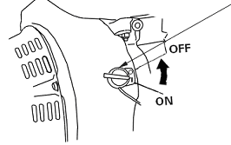
OFF

7. MAINTENANCE

SCHEDULE

REGULAR SERVICE PERIOD |  | Each use | First month or 20 Hrs. | Every 3 months or 50 Hrs. | Every 6 months or 100 Hrs. | Every year or  300 Hrs.
Engine oil | Check level | ○
Engine oil | Change |  | ○ |  | ○
Air cleaner | Check | ○
Air cleaner | Clean |  |  | ○(1)
Air cleaner | Replace
Sediment Cup | Clean |  |  |  | ○
Spark plug | Clean |  |  |  | ○ | Replace
Valve clearance | Check-Adjust |  |  |  |  | ○(2)
Cover comp head | Clean | After every 300 Hrs. (2)
Fuel tank and fuel filter | Clean | Every 2 years (Replace if necessary) (2)
Fuel line | Check | Every 2 years (Replace if necessary) (2)

（1）Service more frequently when used in dusty areas.
（2）These items should be serviced by your servicing dealer unless you have the proper tools and are mechanically proficient.

RENEWING ENGINE OIL
Drain the used oil while the engine is warm. Warm oil drains quickly and completely.

1. Place a suitable container below the engine to catch the used oil, and then remove the pad and dipstick and the drain plug.
2. Allow the used oil to drain completely, and then reinstall the drain plug and pad, and tighten it securely.

Please dispose of used motor oil in a manner that is compatible with the environment. We suggest you take used oil in a sealed container to your local recycling center or service station for reclamation. Do not throw it in the trash; pour it on the ground; or down a drain.

3. With the engine in a level position, fill to upper limit with the recommended oil.

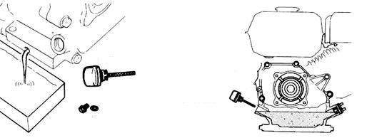
Oil upper limit
Oil dipstick
Drain bolt
Sealing washer

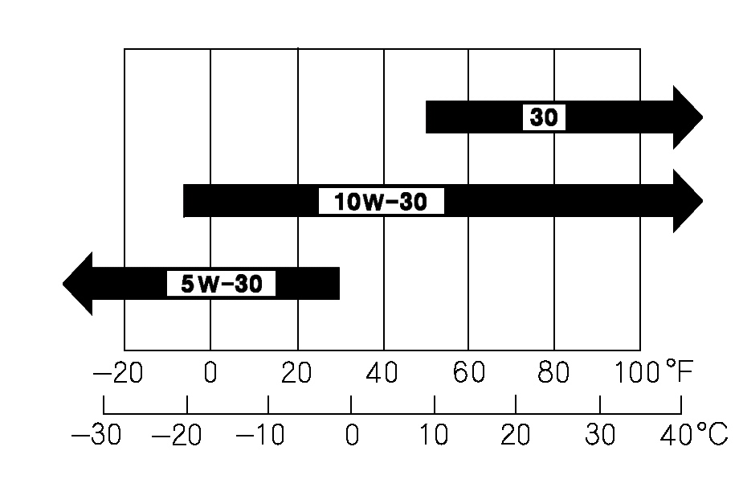

Engine oil capacities：
152F-1/154F-1/156F-1: 0.35 L

Environment temperature
4) Assembling oil dipstick and screwing down

Recommended oil:
Use 4-stroke automotive detergent oil.
We recommend that you use API SERVICE Category SE or SF oil or equivalent to SG grade SAE 10W-30.

You can use this brand oil if your area temperature list within some brand oil temperature range

MAINTAINING AIR CLEANER

A dirty air filter will restrict air flow to the carburetor, reducing engine performance.
If you operate the engine in very dusty areas, clean the air filter more often than specified in the MAINTENANCE SCHEDULE.


Operating the engine without element or with a damaged element will allow dirt to enter the engine, causing rapid engine wear.

Air cleaner

- Screw off air cleaner bolt and remove the cover.

Air cleaner elbow
Support plate
Element
.Nut M6
Cover

Locking nut
- Remove foam element

Check element and renew if damaged.

Wash foam element：
Wash the cover and filter in warm, soapy water, rinse, and allow drying thoroughly. Or clean in nonflammable solvent and allow drying. Dip in clean engine oil, and then squeeze out all excess oil.

Empty the used oil from the air cleaner case, wash out any accumulated dirt with nonflammable solvent, and dry the case.

- Clean the air cleaner l, cover and rubber gasket, preventing dust entering into carburetor.

- Reassemble the foam element, paying attention to rubber gasket underneath the element.

- Reassemble the air cleaner, and tighten the wing nut securely.

WASHING SEDIMENT CUP
(First check fuel tank for fuel, if having, drain the fuel in the fuel tank completely.)
- Remove the fuel sediment cup and O-ring.
- Wash the sediment cup and O-ring in nonflammable solvent, and dry them thoroughly.
- Place the O-ring in the fuel valve, and install the sediment cup. Tighten the sediment cup securely.
- Move the fuel valve to the ON position, and check for leaks. Replace the O-ring if there is any leakage.

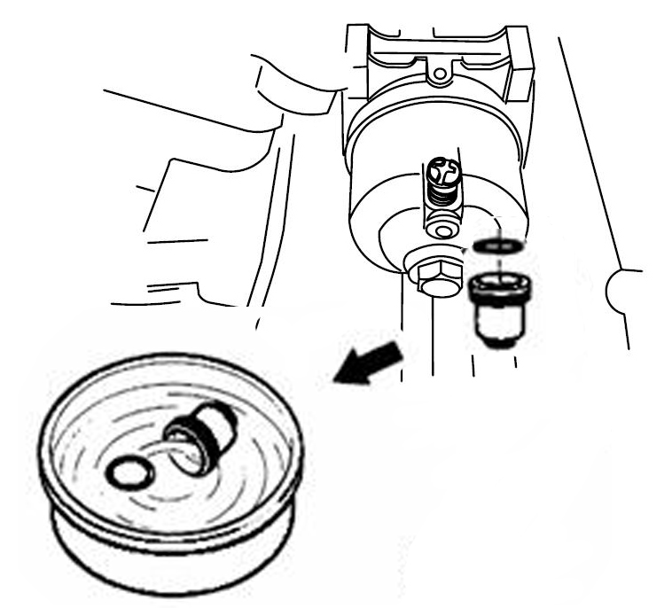
O-ring
Sediment cup

SPARK PLUG
Recommended spark plugs: E7RTC or other equivalents.

An incorrect spark plug can cause engine damage.

1. Disconnect the spark plug cap, and remove any dirt from around the spark plug area.

2. Remove the spark plug with a spark plug wrench.
Spark plug socket
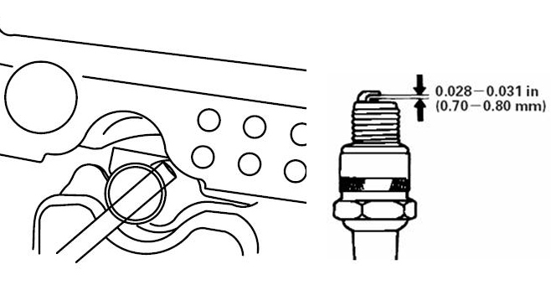
3. Inspect the spark plug. Replace it if the electrodes are worn, or if the insulator is cracked or chipped. The gap should be 0.028 -0.031 in (0.70 - 0.80 mm). Correct the gap, if necessary,
4. Install the spark plug carefully, by hand, to avoid cross-threading.

5. After the spark plug seats, tighten with a spark plug wrench to compress the water.

If reinstalling the used spark plug ，tighten 1/8 - 1/4 turn after the spark plug seats.

If installing a new spark plug, tighten 1/2 turn after the spark plug seats.

6. Assemble spark plug.

ADJUSTING IDLE SPEED

1. Start the engine outdoors, and allow it to warm up to operating temperature.

2. Move the throttle lever to its slowest position.
3. Turn the idle speed screw to obtain the standard idle speed.

Standard idle speed: 2000±150 rpm

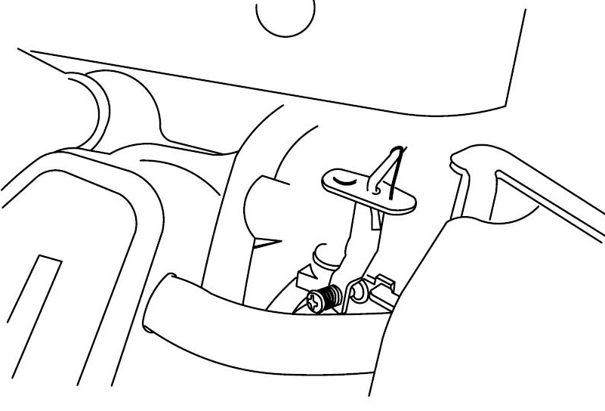
Screw

8. STORING YOUR ENGINE

If the engine has been running, allow it to cool for at least half an hour before cleaning. Clean all exterior surfaces, repair any damaged paint, and coat other areas that may rust with a light film of oil.
CAUTION

Water with big pressure can enter into air cleaner and muffler and even into cylinder along with air path, resulting in causing rust and water spatter on the hot engine to damage engine, so don’t wash engine until the engine is cooled.

- Place a container underneath the carburetor, and use funnel for oil not spattering, close fuel cock.

- Remove the drain plug and sediment cup, then, open the fuel cock.

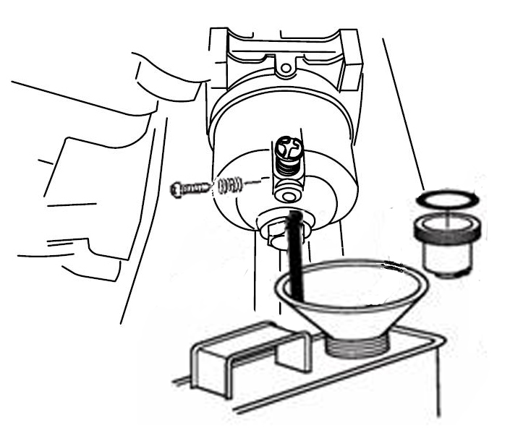
Spring
Bolt
O-ring
Sediment cup
- Immediately reassemble sediment cup and drain bolt after fuel completely draining. And screw down.
- Change the engine oil.
- Remove the spark plugs.
- Pour a tablespoon (5-10 cc) of clean engine oil into the cylinder.
- Pull the starter rope several times to distribute the oil in the cylinder.
- Reinstall the spark plugs.
- Pull the starter rope slowly until resistance is felt. This will close the valves so moisture cannot enter the engine cylinder. Return the starter rope gently.
- Put the out case on the engine and place in the ventilated and dry area.


·The length of time that gasoline can be left in your fuel tank and carburetor without causing functional problems will vary with such factors as gasoline blend, your storage temperatures, and whether the fuel tank is partially or completely filled. The air in a partially filled fuel tank promotes fuel deterioration. Very warm storage temperatures accelerate fuel deterioration. Gasoline will oxidize and deteriorate in storage. Deteriorated gasoline will cause hard starting, and it leaves gum deposits that clog the fuel system. As a result, If the engine is not used for more than one month, the fuel oil shall be drained thoroughly to prevent from deterioration of the fuel in fuel system and carburetor.
·The failures of fuel system or engine performance arising from
improper storage are beyond the scope of the warranty.

9. TROUBLESHOOTING
  - Starting difficult

Phenomenon | Possible Cause |  |  |  | Correction
Cylinder pressure normal | Spark plug normal | Fuel system abnormal | Oil path unpassing | No fuel, oil cock closed | Add fuel, open the oil cock
 |  |  |  | Air hole clogged | Clean clogged
 |  |  |  | Oil cock clogged | wash
 |  |  |  | Main jet adjusted not well, or clogged | Readjust, wash and blow
 |  |  |  | Needle valve or float blocked. | Repair or renew
Cylinder pressure normal | Spark plug normal | Fuel system abnormal | Oil path passing | Fuel too dirt or deteriorated | Renew fuel or clear carburetor
 |  |  |  | Water in the fuel | Renew fuel and clean carburetor
 |  |  |  | Too much fuel in the cylinder | Drain fuel and clean spark plug
 |  |  |  | Wrong fuel | Chang fuel
Cylinder pressure normal | Fuel system normal | Spark normal | Spark plug poor | Carbon deposit and dirt electrode | Clean carbon deposit and dirt
 |  |  |  | Damaged insulator | Renew spark plug
 |  |  |  | Electrode burn through. | Renew spark plug
 |  |  |  | Wrong gap | Adjust gap
Cylinder pressure normal | Fuel system normal | Spark normal | No spark | High tension coil damaged | Renew high tension coil
 |  |  |  | Igniter coil damaged | Renew high tension coil
 |  |  |  | Magnetic field strength not enough | Charge magnetic or renew
Cylinder pressure abnormal | Fuel system normal | Igniter normal | Spark plug normal | Piston ring worn or broken. | Renew
 |  |  |  | Ring cementation | Clean carbon deposit
 |  |  |  | No washer or not tightening | Add washer or tighten
 |  |  |  | Leaking from joint | Renew gasket
 |  |  |  | valve sealing poor | Lap or renew

、

2）ENGINE LACKS POWER

Phenomenon | Possible Cause |  | Correction
When increasing throttle speed up slowly or speed down or stop the engine | Ignition system | Ignition time not right | Replace ignition coil
 | Fuel system | Fuel path with air | Exhaust air
 | Fuel system | Wrong adjustment of main jet | Readjustment
 | Fuel system | Needle valve and main jet clogged | Clean and blow
 | Fuel system | Oil cock clogged | Clean or replace
 | Fuel system | Carbon deposit in the combustion chamber | Clean carbon deposit
 | Intake system | Air cleaner clogged | Clean or replace
 | Intake system | Intake system clogged | Repair or replace
 | Compression poor | Piston, cylinder piston ring worn | replace
 | Compression poor | Leakage between cylinder and cylinder head | Replace cylinder head gasket
 | Compression poor | Valve gap not right | Readjustment
 | Compression poor | Valve sealing leakage | Grinding or replacement

3）SUDDENLY STOP THE ENGINE
Phenomenon | Possible Cause |  | Correction
Suddenly stop in running | Fuel system | No fuel | Refuel and pass through
Suddenly stop in running | Fuel system | Carburetor clogged | Check fuel path
Suddenly stop in running | Fuel system | Carburetor float leaking fuel | Repair float
Suddenly stop in running | Fuel system | Needle valve blocked | Repair
Suddenly stop in running | Ignition system | Spark plugs breakdown,  carbon deposit short circuit | Replace spark plug
Suddenly stop in running | Ignition system | Spark plug electrode fallen off | Replace spark plug
Suddenly stop in running | Ignition system | High tension line fallen off | Repair and replace
Suddenly stop in running | Ignition system | Ignition coil breakdown | Replace
Suddenly stop in running | Others | Serious scuffing and valve fallen off | Repair or replace damaged parts

- ENGINE OVERHEATING

Phenomenon | Possible Cause | Correction
Gasoline engine overheating | Ignition time not right | Replace ignition coil
Gasoline engine overheating | Gasoline not enough | Refill gasoline
Gasoline engine overheating | Exhaust pipe clogged | Clean exhaust pipe
Gasoline engine overheating | Guided air shield clogged | Repair
Gasoline engine overheating | Air path clogged | Clean air cooling fin
Gasoline engine overheating | Cooling fan damaged | Reinstall
Gasoline engine overheating | Gas leaking from ring to down | Replace damaged parts
Gasoline engine overheating | Gasoline engine speed too high | Check and governor speed system or replace speed gear
Gasoline engine overheating | Crankshaft bearings burned | Replace or repair

5） Abnormal sound
Phenomenon | Possible Cause | Correction
Knocking sound | Piston and piston ring worn | Replace damaged parts
Knocking sound | Connecting rod,piston pin and pin hole worn | Replace damaged parts
Knocking sound | Crankshaft bearings worn | Replaces or repair
Knocking sound | Piston rings broken | Replace piston rings
Deflagration and metal sound | Combustion charmer carbon deposit too much | Clean carbon deposit
Deflagration and metal sound | Spark plug electrode gap too narrow | Adjust electrode gap
Deflagration and metal sound | Engine flooded with fuel | Check carburetor
Deflagration and metal sound | Wrong fuel | Replace fuel
Deflagration and metal sound | Gasoline engine overheating | Refer to overheated trouble column
Other abnormal sounds | Valve gap adjustment wrong | Readjust valve gap
Other abnormal sounds | Flywheel connection with crankshaft loosen | Replace connecting key and reinstall

10. ENGINE PARAMETER
Model |  | 152F-1 | 154F-1 | 156F-1
Type |  | Single cylinder 4-Stroke Forced air cooling OHV
Rated power  (kW/3600rpm) |  | 1.5Kw/3600rpm | 2Kw/4200rpm | 2.2Kw/4200rpm
Max torque (N·m/rpm) |  | 4N.m/3400rpm | 4.5N.m/3800rpm | 5N.m/3800rpm
Fuel consumption ratio  (g/kW·h) |  | ≤450
Idle speed (rpm) |  | 2000±150
Speed fluctuating ratio |  | ≤10%
Noise ≤ dB(A) |  | 90 | 93 | 97
Bore×Stroke(mm) |  | 52X37 | 54×38 | 56X40
Displacement(cc) |  | 79cc | 87cc | 99cc
Compression ratio |  | 8.5:1 | 8.5:1 | 9.0:1
Lubricating mode |  | Splash
Staring mode |  | Recoil start
Rotation |  | Anti-clockwise(from P.T.O.Side)
Valve clearance(mm) |  | Intake valve 0.10-0.15  Exhaust valve 0.15-0.20
Spark plug gap(mm) |  | 0.7~0.8
Ignition mode |  | Transistorized magneto ignition
Air cleaner |  | Single element
Dimension mm | Length |  | 310
Dimension mm | Width |  | 260
Dimension mm | Height |  | 305
Net weight (kg) |  |  | 10.5

The power rating of the engine indicated in this document is the net power output tested on a production engine for the engine model and measured in accordance with SAE J1349 at 3,600/4200 rpm (Net Power) and at 3,800 rpm (Max. Net Torque). Mass production engines may vary from this value.
Actual power output for the engine installed in the final machine will vary depending on numerous factors, including the operating speed of the engine in application, environmental conditions, maintenance, and other variables.

11. WIRING DIAGRAMS

Non-electric starting engine with oil protection system
Bl | black
Y | yellow
G | green
Engine switch WIRINGIGESTBATOFFOOONSTARTOO

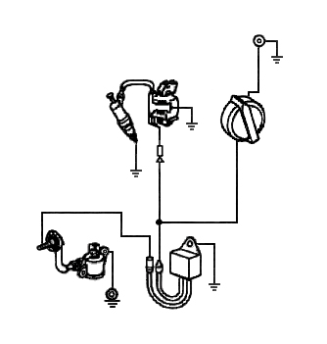

Transistorized ignition unit

Engine switch
Spark plug

Bl
Y
Y

Oil sensor

Y
Bl
Oil alert unit

